**AWS-FACE DETECTION APP**

**Divya Khemka**

**17BIS0051**

AWS-LOGIN PAGE

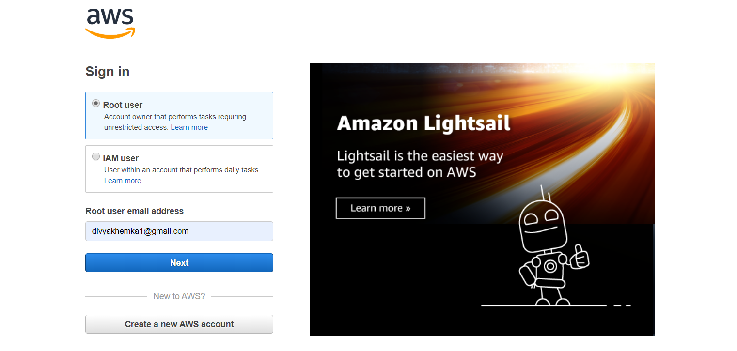

EC2-DASHBOARD

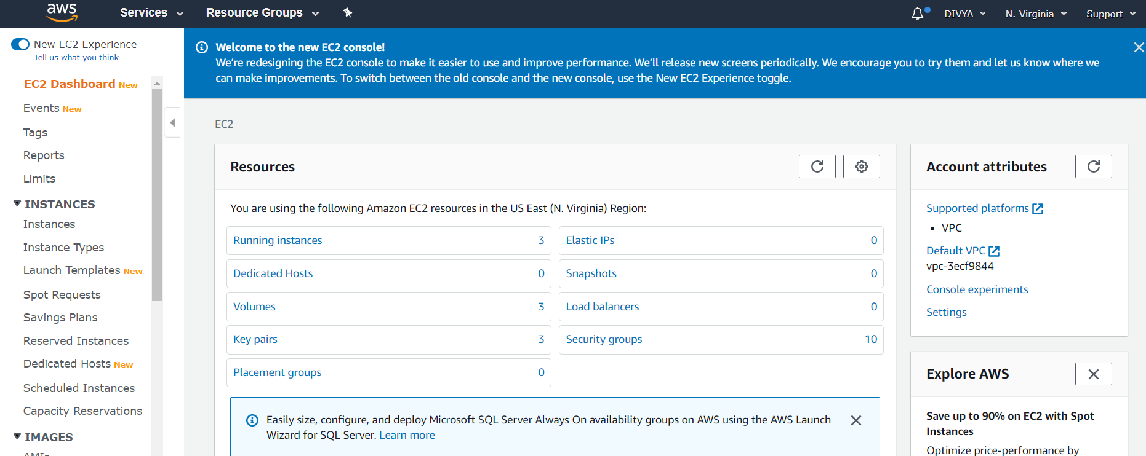

S3 Dashboard

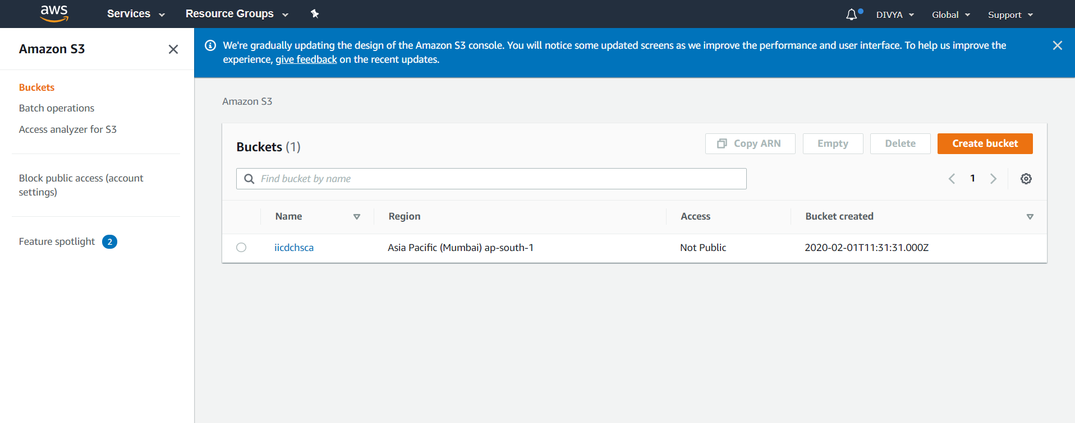

Rekognition Dashboard

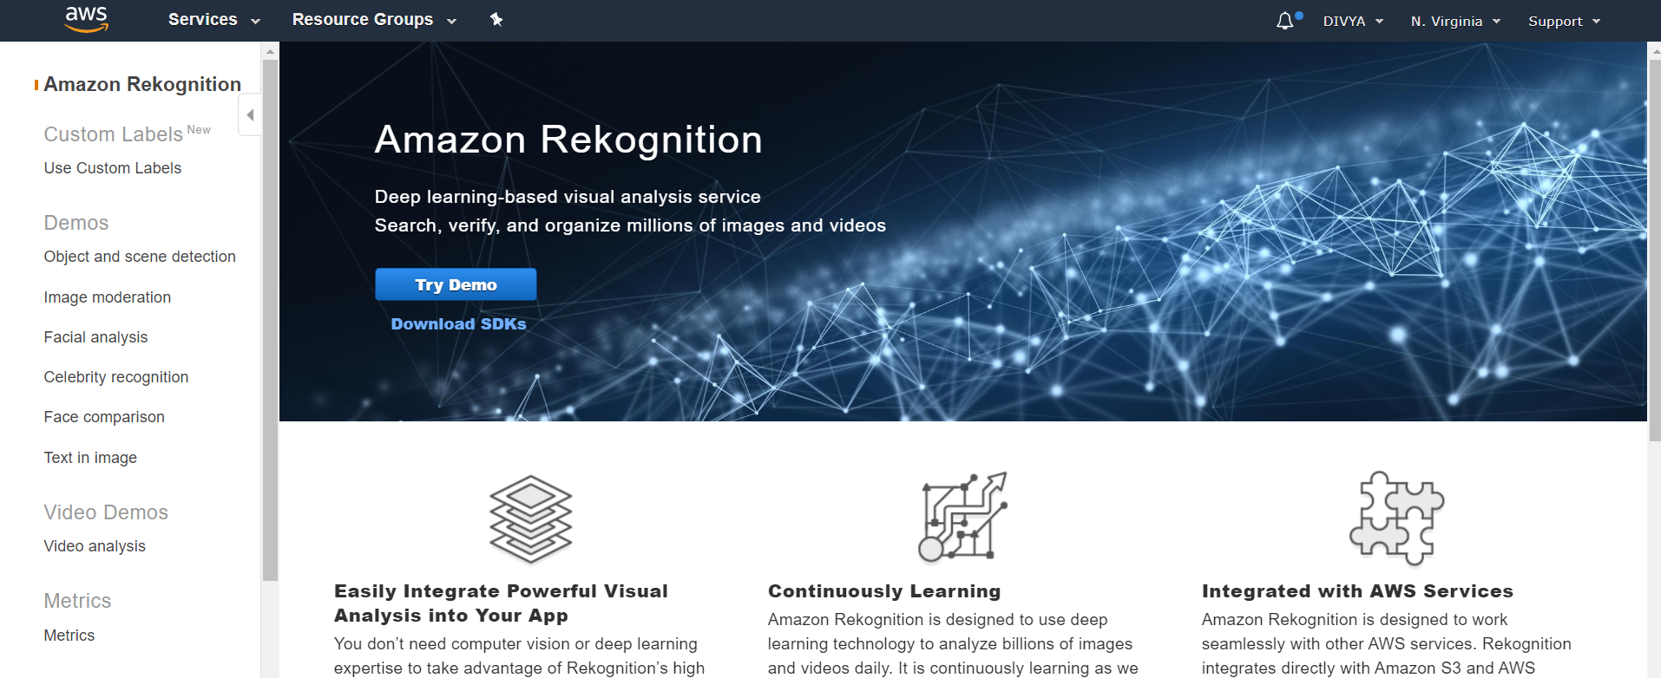

SCREENSHOTS FOR EC2

1.CHOOSING AN AMI

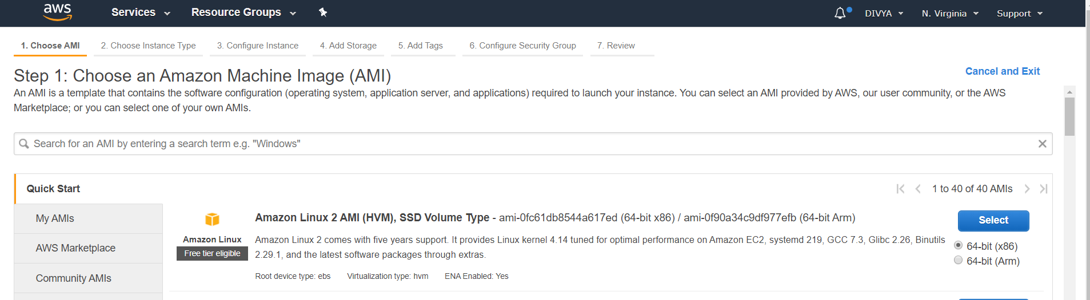

2.CHOOSING AN INSTANCE TYPE

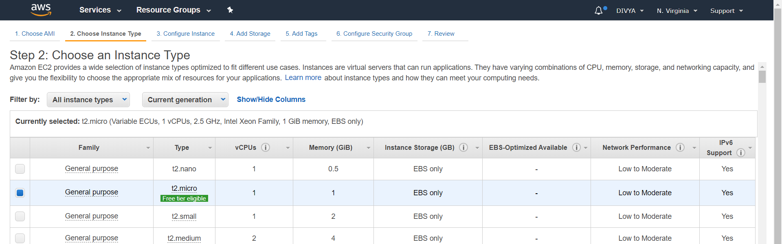

3.ADDING STORAGE

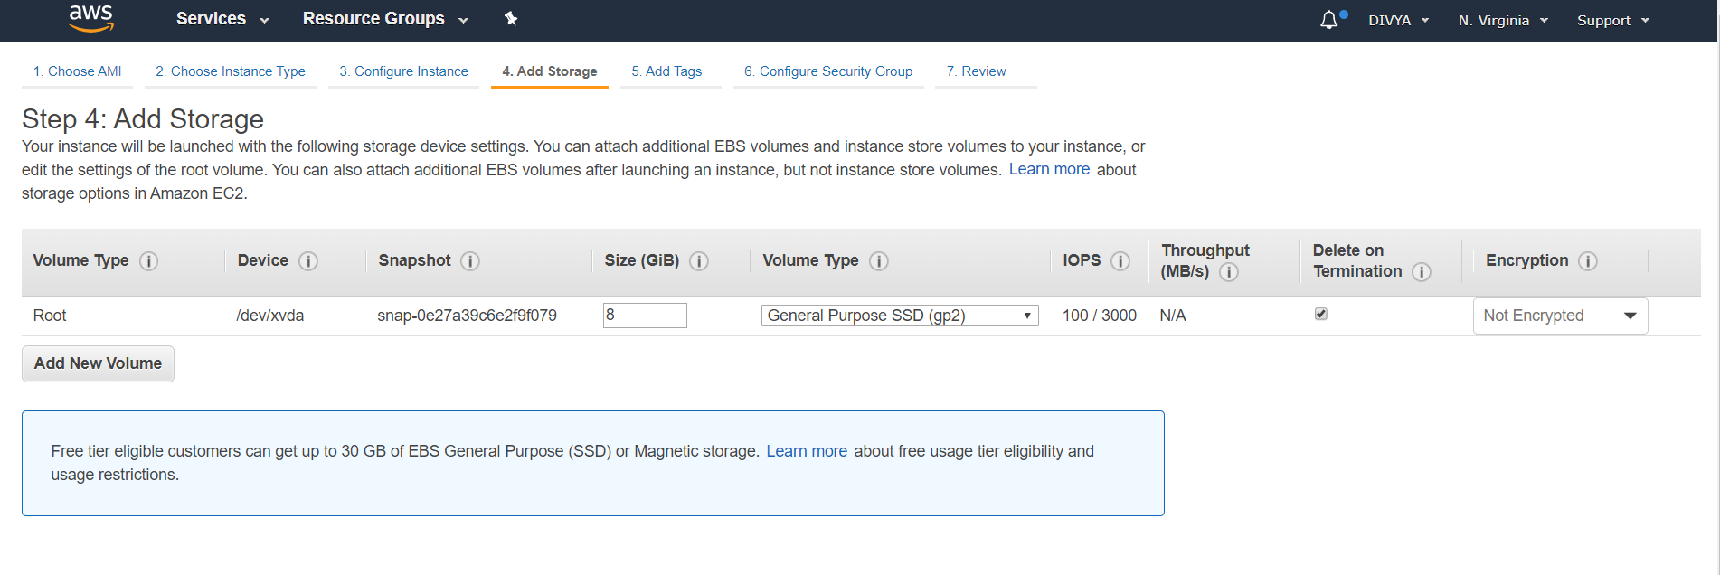

4.SECURITY GROUP CONFIGURATION

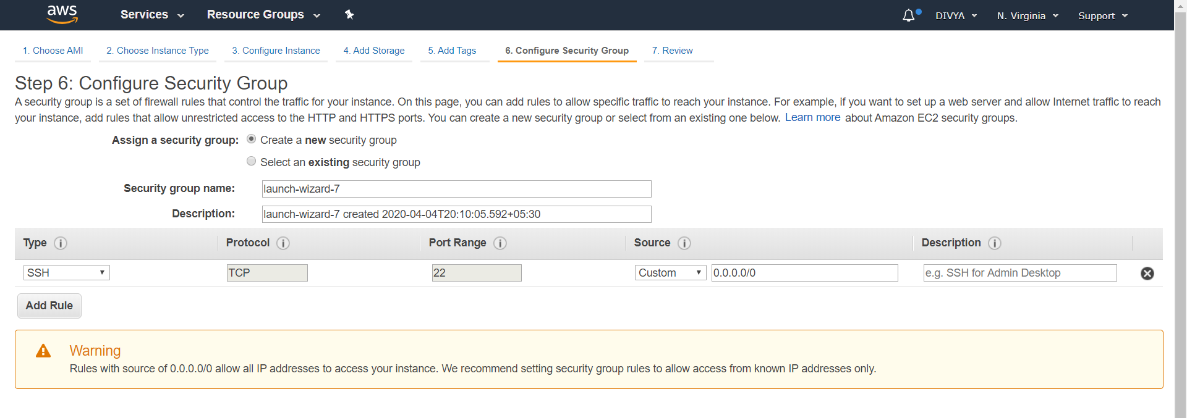

5.KEY PAIR DOWNLOAD

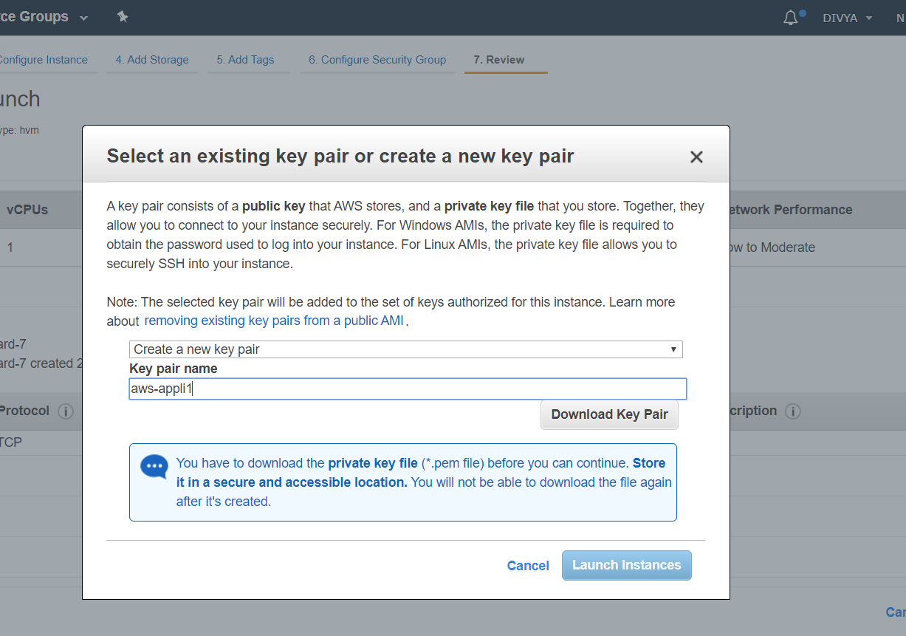

6. PuTTYgen conversion from pem to ppk

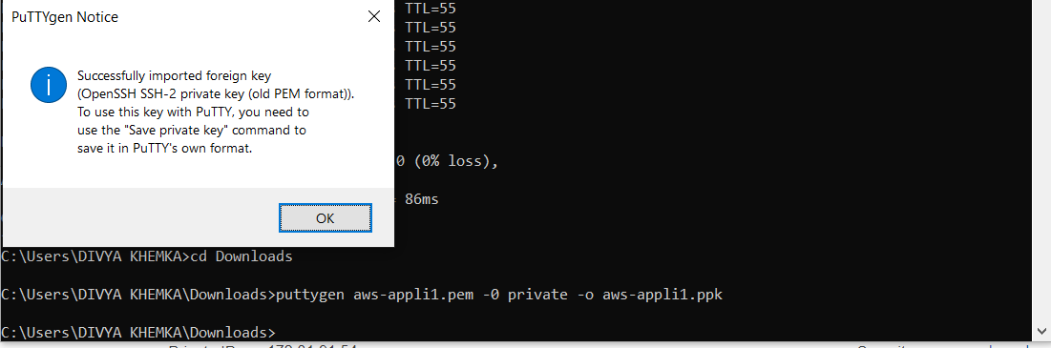

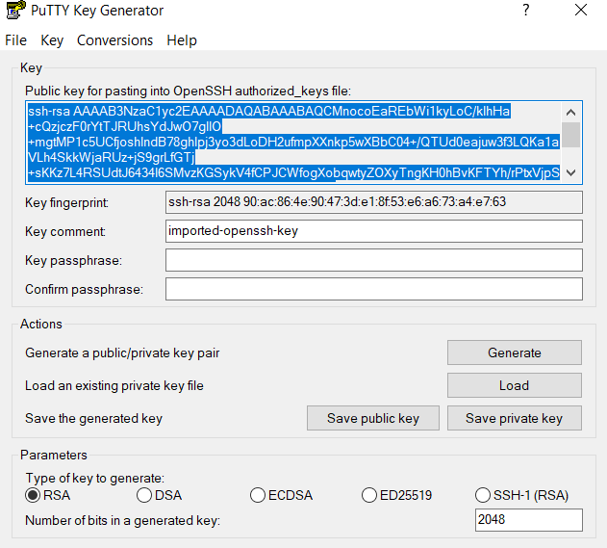

7. Logged in EC2 black screen

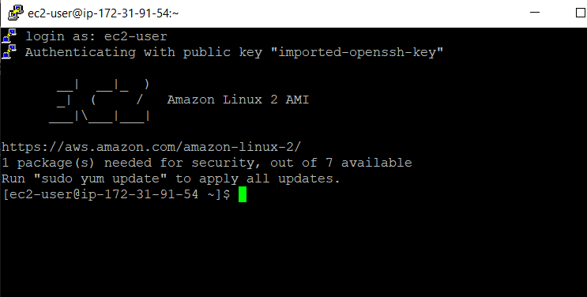

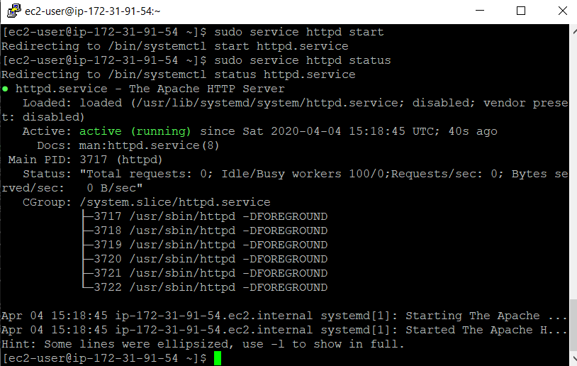

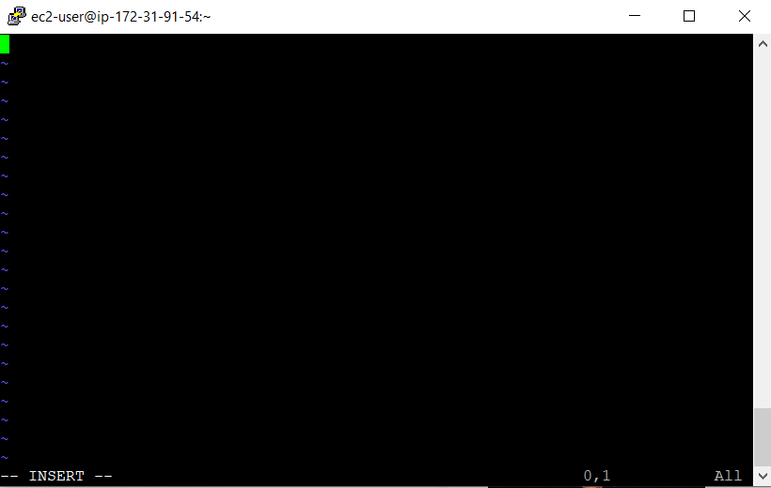

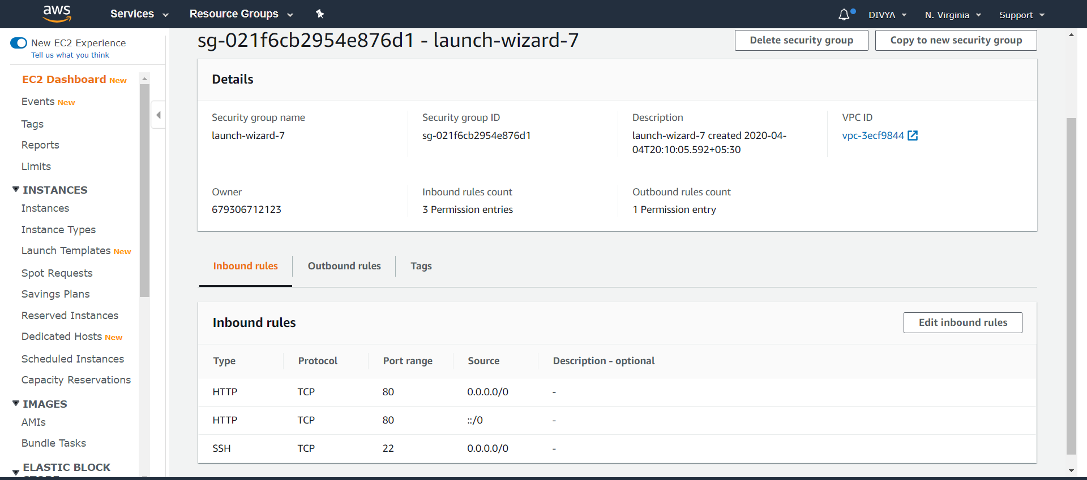

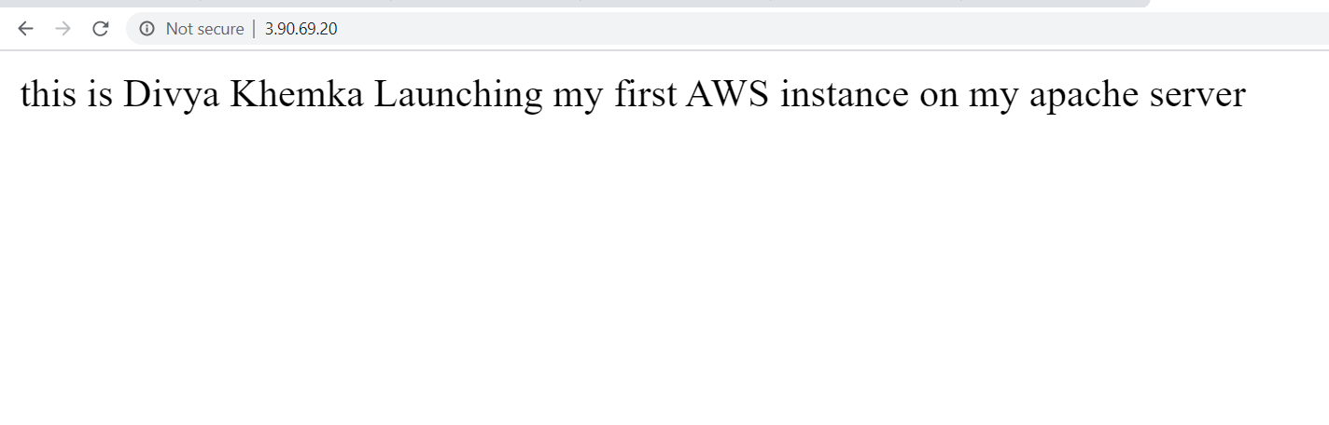

S3 Dashboard

CREATING A BUCKET

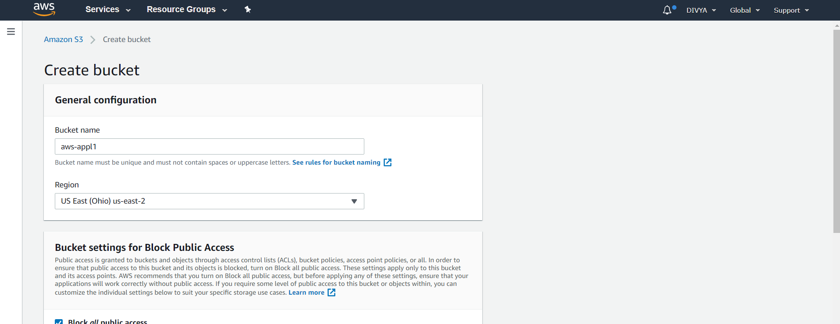

UPLOADING AN OBJECT

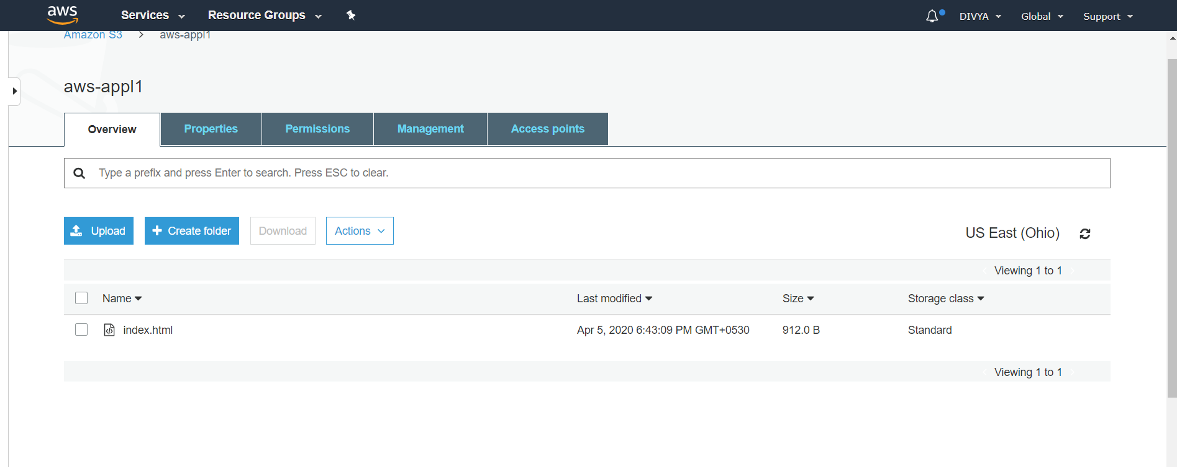

STATIC WEBSITE HOSTING

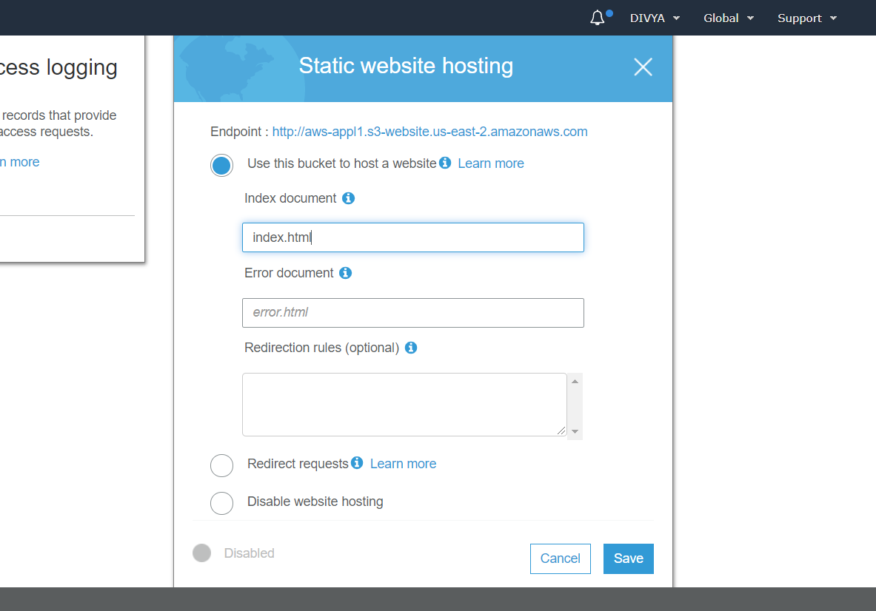

ENABLING PUBLIC ACCESS FOR REMOVING THE FORBIDDEN ACCESS

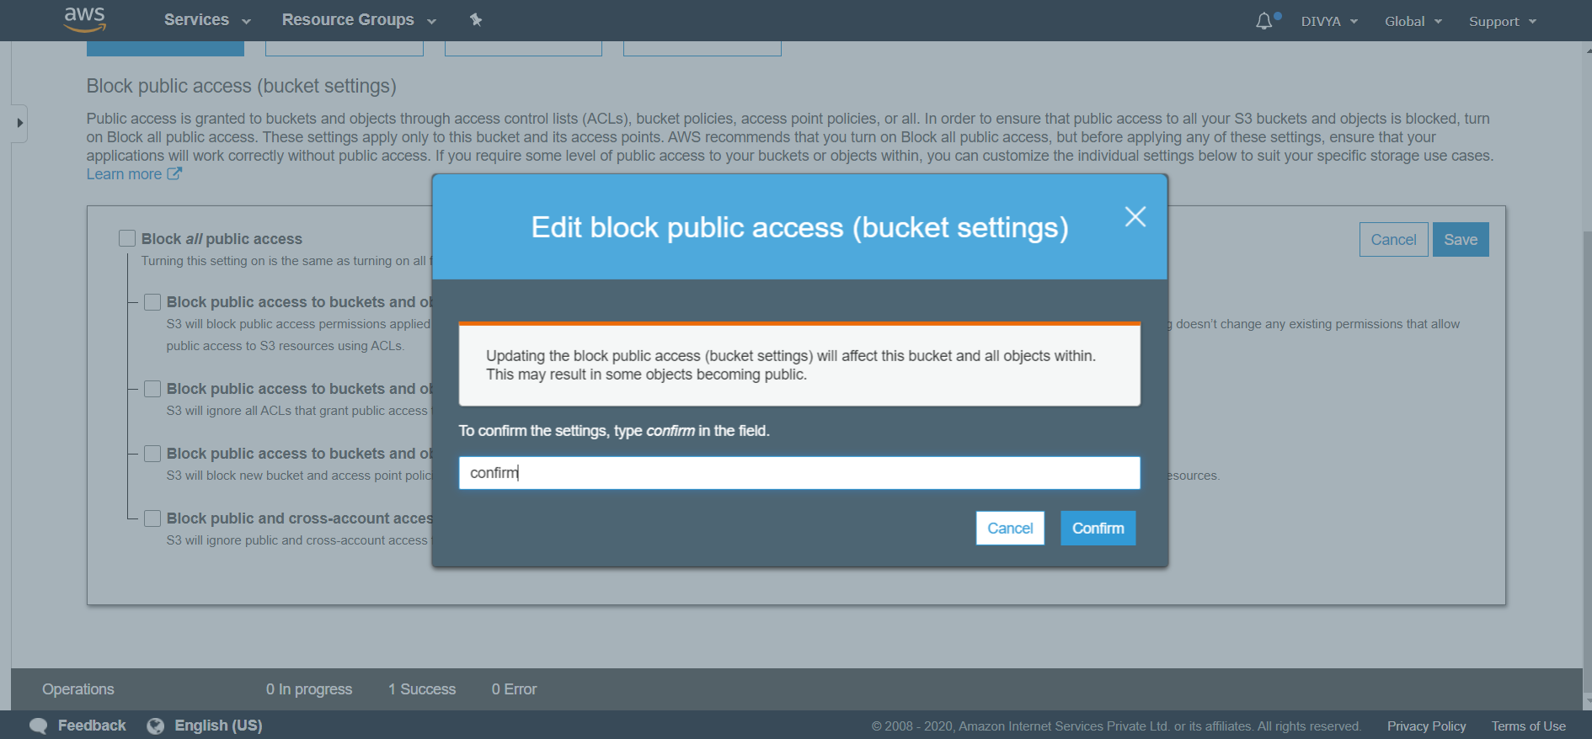

MAKING THE OBJECT PUBLIC

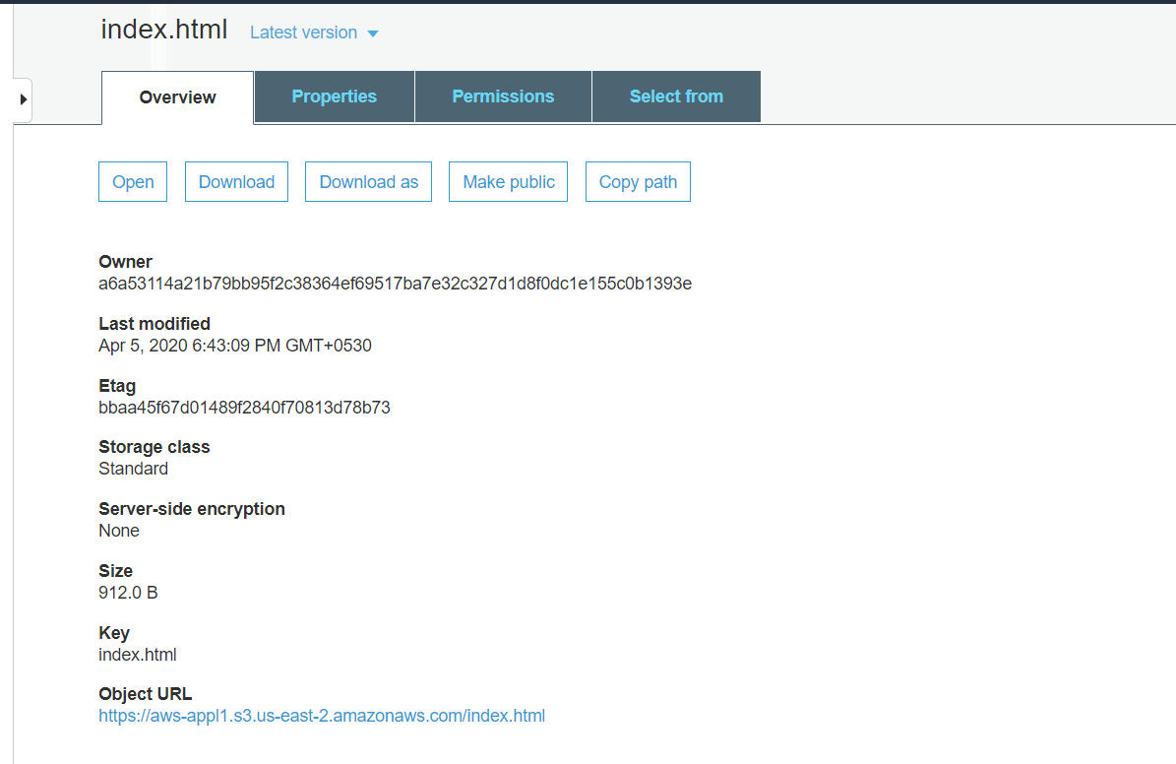

S3 LINK ON BROWSER

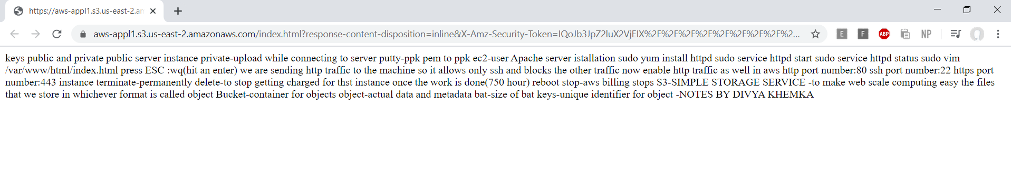

REKOGNITION

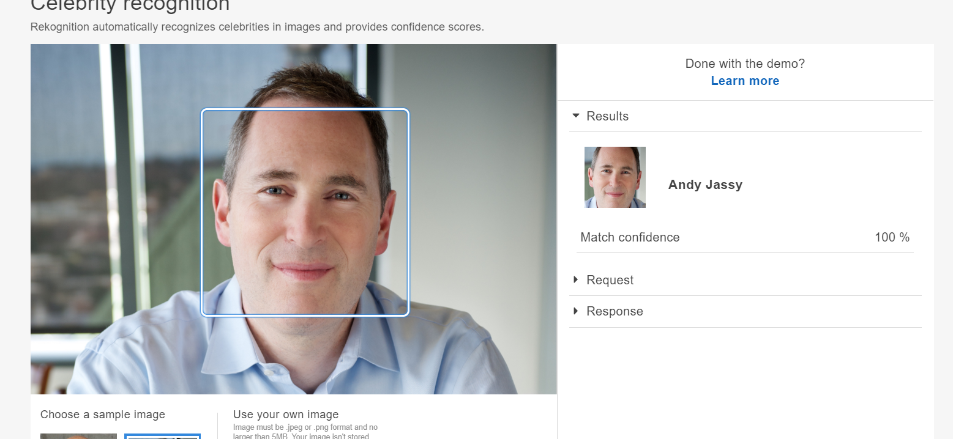

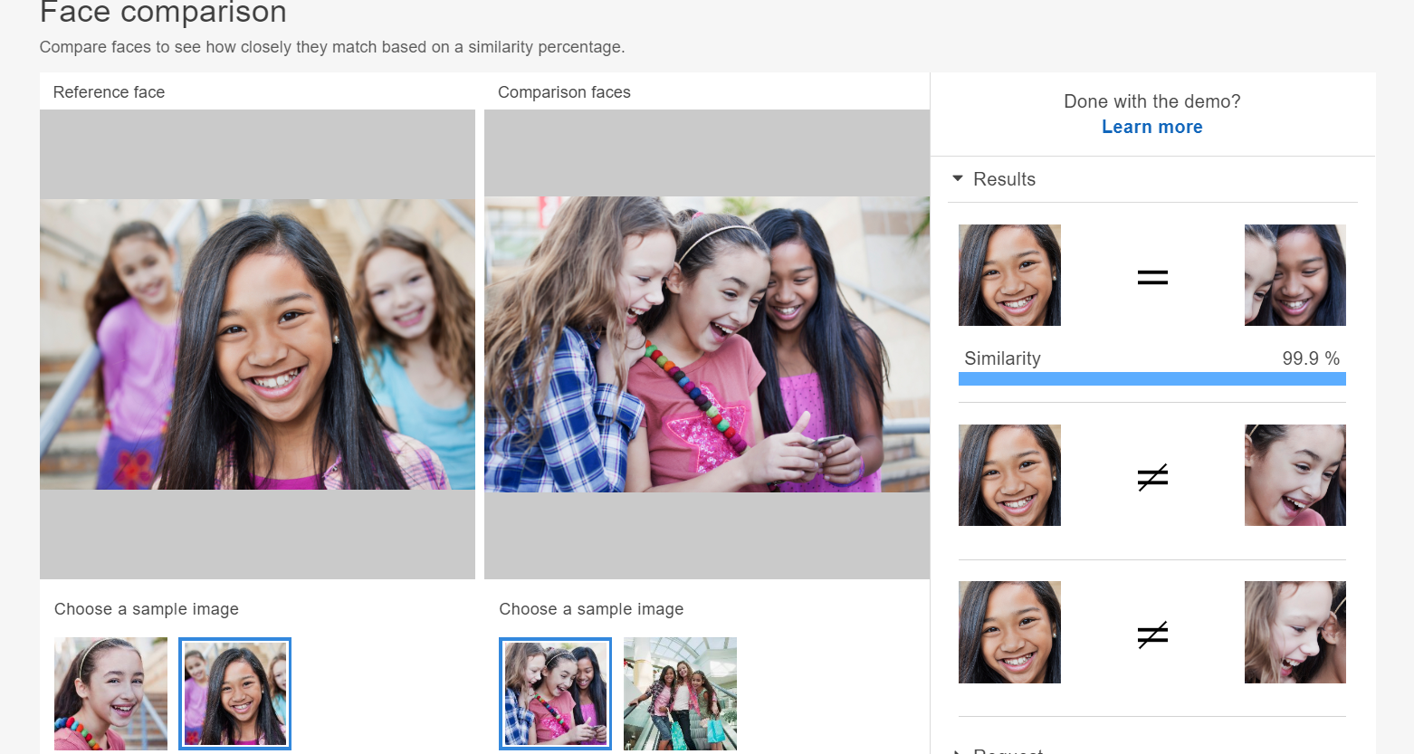

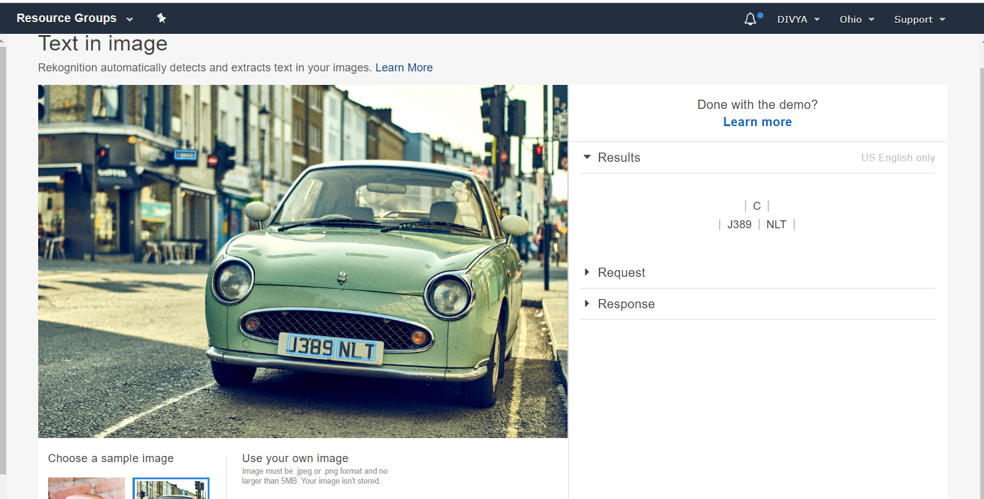

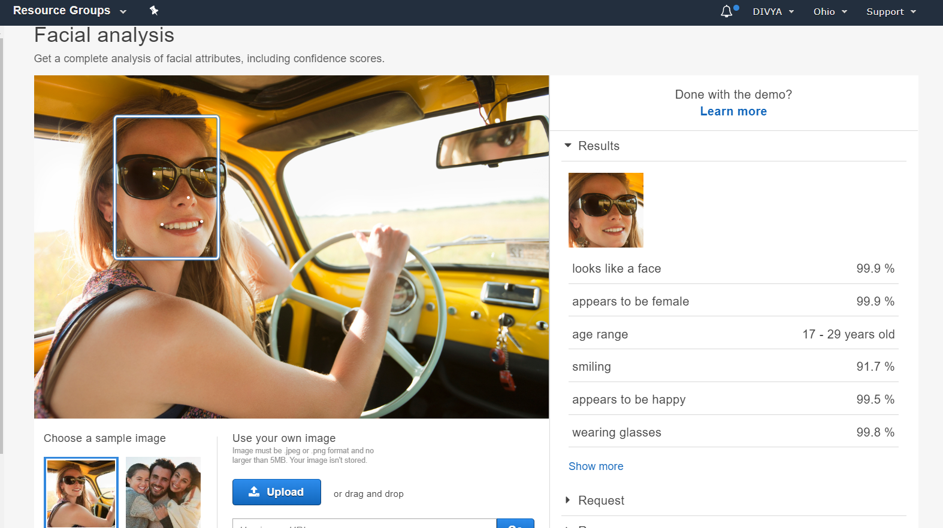

EC2 AND S3

INSTALLING PHP

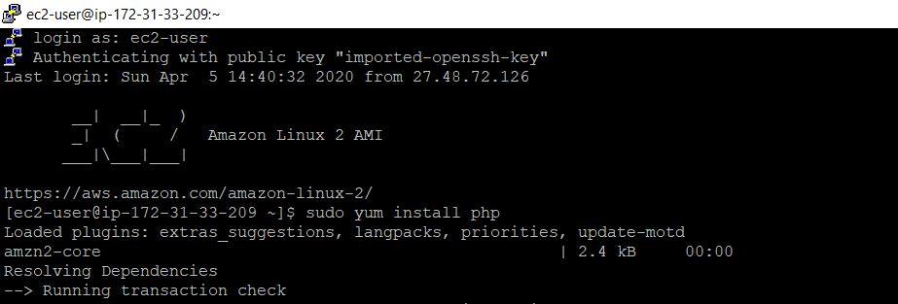

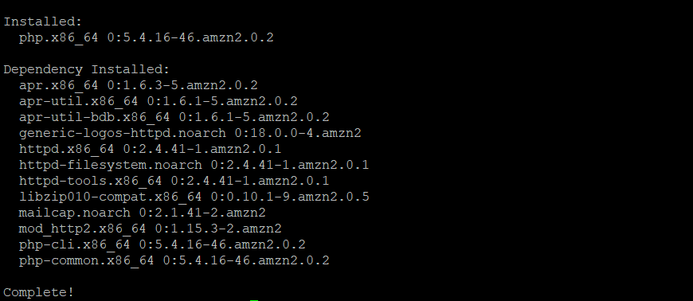

INSTALLING COMPOSER

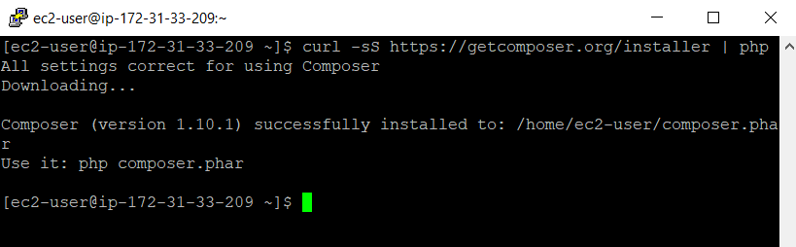

DOWNLOADING AN IMAGE

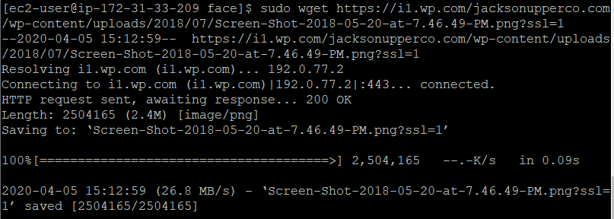

INSTALLING AWS SDK

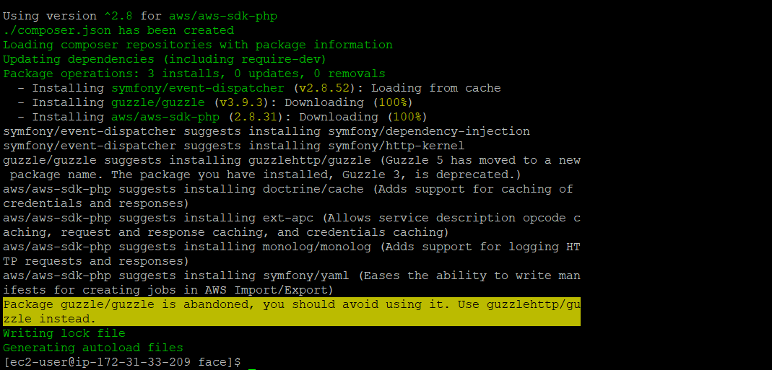

Index.php

